SOLAR HILL NEWS
Solar Hill Historic District Association
203 Solar Street, Bristol, VA 24201 (276) 466-9265 203solar@charter.net

February 2004
Board: Bud Phillips
Tony Holbrook Peter Lawrie
Nina Rizzo
Robert Rogers

Director: Deborah Jones
Secretary/Treasurer: Susan Long
Architect: Peter Lawrie
Photographer: Neil Staples

We Need You At February 24 City Council Meeting

Dear Neighbors:

After much hard work by our officers, the Virginia Department of Transportation (VDOT) grant application is complete and the Solar Hill Revitalization Project has been tentatively approved by the Metropolitan Planning Organization (MPO), the first step toward realization.

Bristol City Council must pass a resolution of support before the project can be submitted to VDOT. To get that approval, a strong showing of neighborhood support is needed at the February 24 City Council meeting which will be held at 7 PM, City Hall, 300 Lee Street. We need as many of you as possible to show up at that meeting.
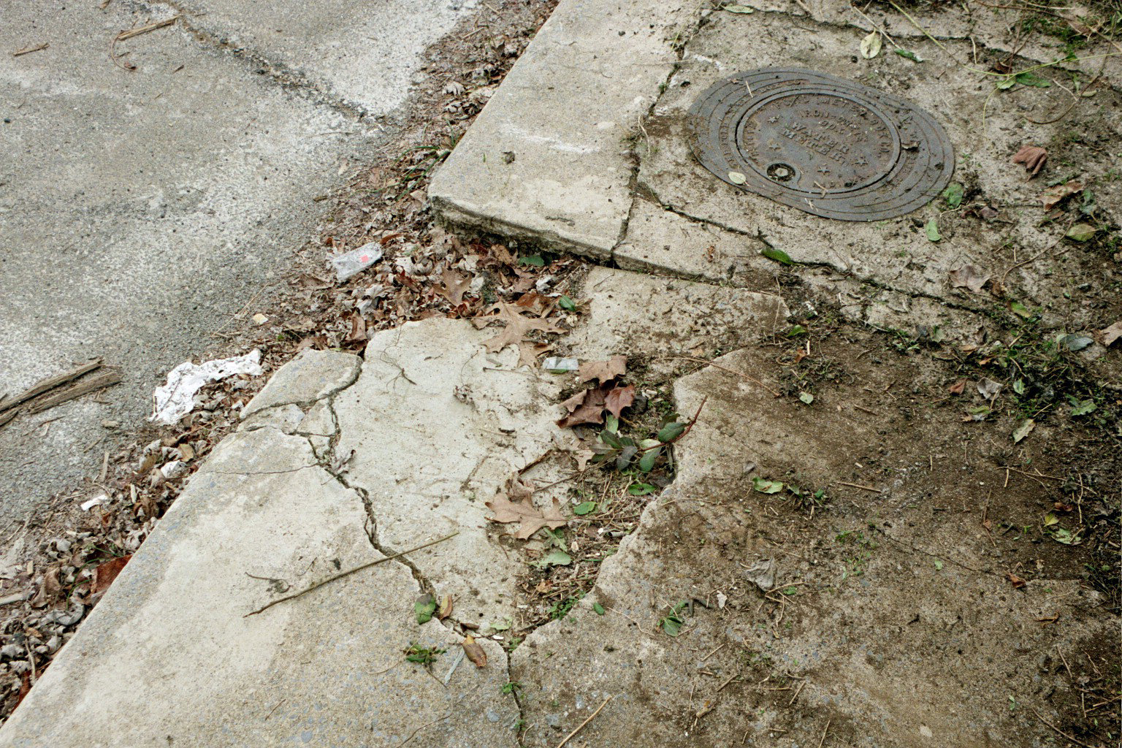
The Solar Hill Revitalization Project proposes to replace deteriorated sidewalks, install decorative post streetlights and street-side landscaping, bury overhead cables, place historic markers throughout the district, and erect a commemorative monument for the area.

The project will provide improvements that the city alone could not afford to fund. It has been tailored for the VDOT Enhancement Program, which funds transportation projects, including pedestrian projects.

Sidewalk replacement is at the heart of the project. It also has scenic beautification and historic/ educational components (see back page). These aspects meet Enhancement Program requirements for “improvements that increase the value or worth of a project or make it more aesthetically pleasing. They should provide a ‘quality-of-life’ benefit.”
In 1999 Bristol matched a $10,000 grant awarded by the Virginia Department of Historic Resources to survey the area. That investment paid off in 2001 when Solar Hill became the first Bristol, Virginia neighborhood listed on both the Virginia Landmarks Register and the National Register of Historic Places.

But although the neighborhood has garnered state and federal recognition, without further improvements, it is in danger of falling into a state of gradual decay.

People see the beautiful old homes and overlook the deteriorating infrastructure around them. In some places sidewalks are practically impassible or do not exist, ugly overhead cables and industrial-style lights mar the character of the neighborhood, and there is little scenic beauty. It is depressing to those who recognize the area’s architectural and historic significance.

The project will revitalize an area that is valuable to Bristol’s history and economics. The district is located in Census Tract 202, which the city targeted for neighborhood revitalization in its 2000-2005 Consolidated Plan: “Revitalization on even a small scale is critical to Bristol, Virginia in its attempts to build a thriving economy and encourage growth.”

If approved by City Council, the project will face stiff competition as hundreds of other projects throughout the state compete for funding. We will resubmit the application until it is fully funded. See you Feb. 24!
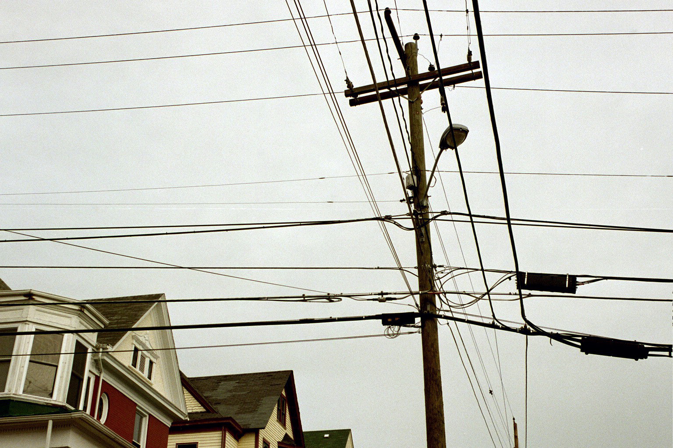
Deborah Jones, Director

What the Revitalization Project Can Do for Solar Hill

NOW:

Deteriorated Sidewalks
Many sidewalks are practically impassible because they are crumbling, broken, cracked, or uneven. In some locations, sidewalks never existed. Consequently the district cannot be fully enjoyed by local residents or tourists who might otherwise be drawn to the area’s architectural and historical attractions.

Inappropriate/Inadequate Street Lights
The district is currently lit with street lights attached to telephone poles with overhead cables and tall industrial-style metal poles. Lights, poles and multi-strand cables mar the character of the historic district. They tend to draw attention to themselves and detract from the beauty of the area’s historic buildings.

Lack of Scenic Beauty
Solar Hill is sadly lacking scenic beauty. Although the area contains many beautiful homes, the streetscape is bleak. Because the sidewalks are so badly deteriorated, weeds are often allowed to grow in the sidewalks and alongside them.
Loss of History
Currently no markers exist to draw attention to the listing of Solar Hill on the National Register of Historic Places and Virginia Landmarks Register. Consequently pedestrians cannot fully appreciate the area’s historic significance.

While the history of the area has been well documented in books, the public is generally unaware of it. Lacking solid knowledge about their area, residents cannot adequately relay it to visitors, who are left guessing at the meaning of things.

THEN:

Revitalization Project Improvements
The Solar Hill Revitalization project will improve the neighborhood in the following ways:

- Sidewalks. The project will replace badly deteriorated sidewalks throughout the district and install new sidewalks where none currently exist.
- Street Lights. Lighting, which is currently only geared toward lighting streets, will be replaced with historically-appropriate post lights at intervals adequate for pedestrians. Distracting overhead cables will be buried.
- Portal/Gateway Monument. A portal monument will be placed at a key location to commemorate the significance of the area and serve as an anchor for walking tours.
- Markers. Historic markers will be located throughout the district to educate pedestrians about the history of the area.
- Walking Tour Maps. A brochure holder will be attached to one marker to provide walking tour maps containing information about the area’s historic streets, sites, people and buildings.
- Landscaping. Limited street-side landscaping will be provided at key locations to further enhance the district and provide pedestrians with some scenic beauty which is sadly currently lacking.
If you feel these improvements will benefit the neighborhood, please show up Feb. 24!

