SOLAR HILL NEWS
Solar Hill Historic District Association
203 Solar Street, Bristol, VA 24201 (276) 466-9265 203solar@charter.net

January 2004
Board: Bud Phillips
Tony Holbrook Peter Lawrie
Nina Rizzo
Robert Rogers

Director: Deborah Jones
Secretary/Treasurer: Susan Long
Architect: Peter Lawrie
Photographer: Neil Staples

Solar Hill Pins Hopes on Revitalization Funds

The Solar Hill Historic District Association (SHHDA) has completed a Virginia Department of Transportation (VDOT) Enhancement Program application which seeks to improve the historic neighborhood.
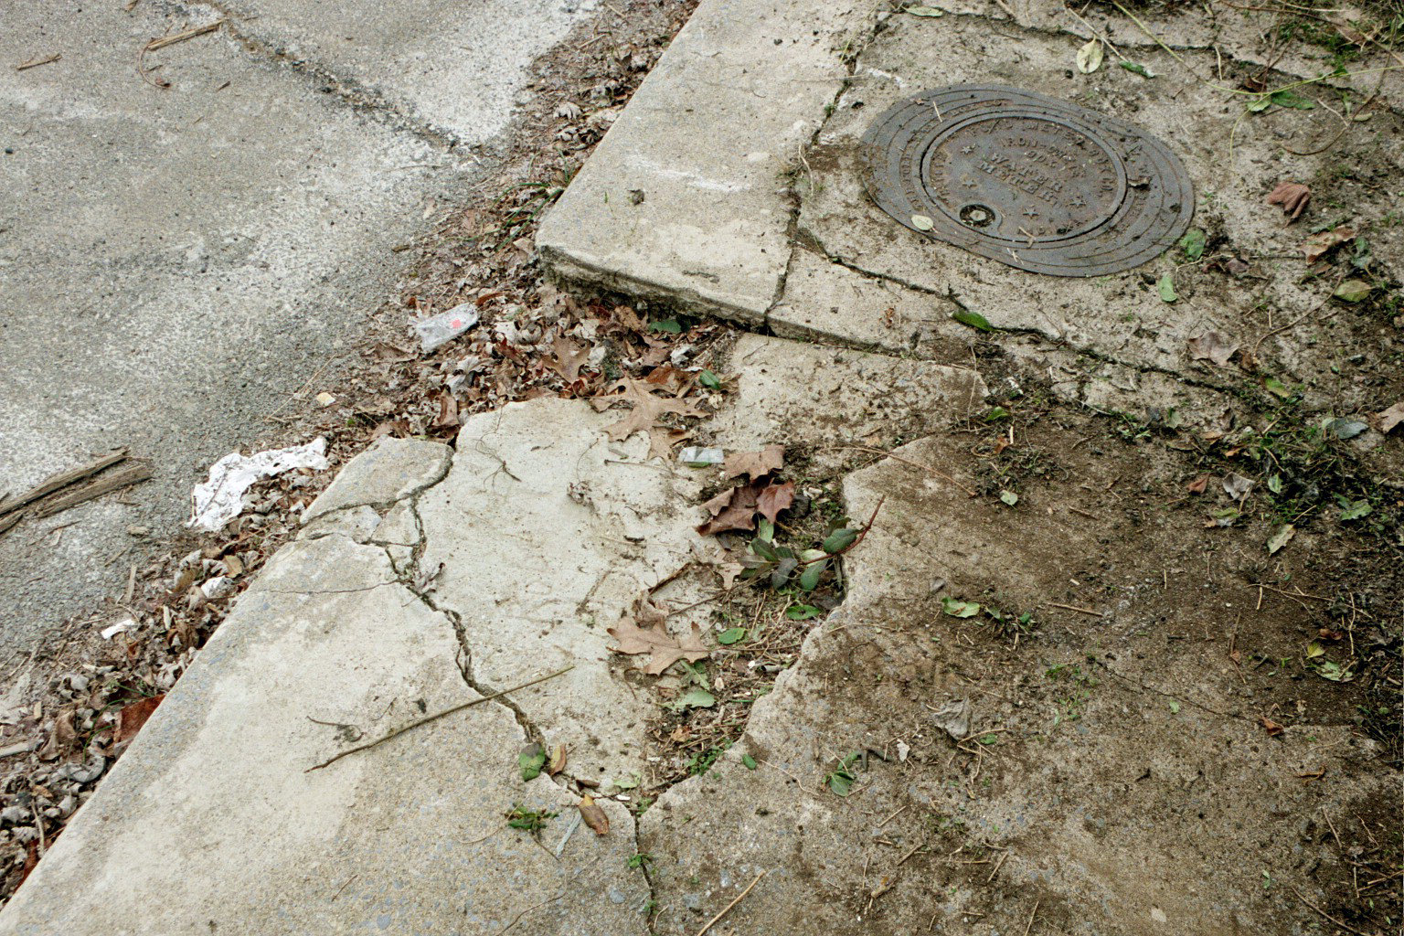
The Solar Hill Revitalization Project proposes to replace deteriorated sidewalks, install decorative post streetlights and street-side landscaping, bury overhead cables, place historic markers throughout the district, and erect a commemorative monument for the area.

In 1871 Solar Hill became the first land developed for residential expansion in Bristol. It became the city’s first neighborhood of significant architectural import. Homes range in age from the early 1800s to the early 1900s with many fine examples of Colonial, Victorian, Neoclassical and Craftsman styles.

Knowing its historic potential, in 1999 Bristol matched a $10,000 grant awarded by the Virginia Department of Historic Resources to survey the area. An impressive 92% of the area’s 117 ‘primary’ buildings were determined to contribute to the character of the district.

That investment paid off in 2001 when Solar Hill became the first Bristol, Virginia neighborhood listed on both the Virginia Landmarks Register and the National Register of Historic Places.

But although the neighborhood has garnered state and federal recognition, supporters say it is in danger of falling into decay.
“People see these beautiful old homes and overlook the deteriorating infrastructure around them,” says SHHDA Director Deborah Jones. “In some places sidewalks are practically impassible or do not exist, ugly overhead cables and industrial-style lights mar the character of the neighborhood, and there is little scenic beauty. It is depressing to those who recognize the area’s architectural and historic significance.”

Jones says the project will revitalize an area that is strategically valuable to Bristol’s history, tourism and economics.

The district is located in Census Tract 202, which (along with Census Tract 203) the city targeted for neighborhood revitalization in its 2000-2005 Consolidated Plan, which states: “Revitalization on even a small scale is critical to Bristol, Virginia in its attempts to build a thriving economy and encourage growth.”
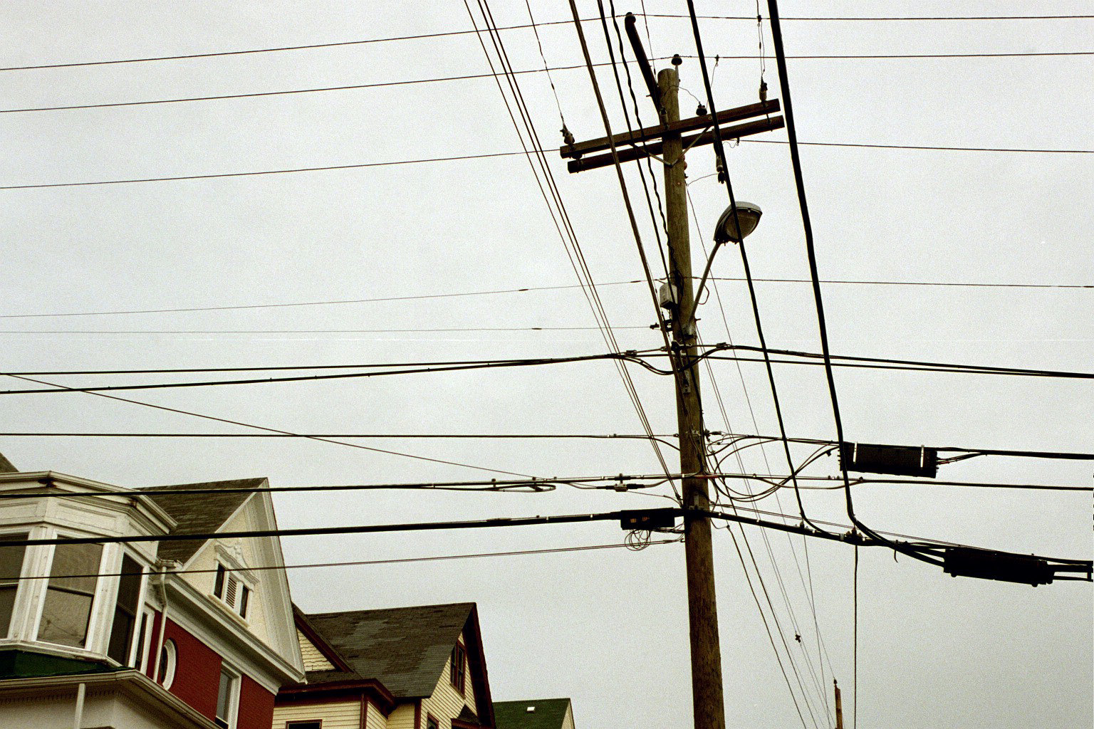

Before it can be submitted to VDOT, the project must first be approved by both the Bristol Metropolitan Planning Organization (MPO) and the Bristol City Council. It will go before the MPO board on January 27, where it is anticipated to be approved contingent upon city approval. City council will consider passing a resolution of support for the project on February 10.

If approved at the local level, the project will face stiff competition as hundreds of other projects throughout the state compete for funding. Jones says the project will be resubmitted until it is funded.

Historic Solar Hill Highlights

The history of Solar Hill extends back to 1814 when James King purchased the land, which he developed into a plantation. The prominent hill upon which he built his home would later be known as Solar Hill. In 1871 Solar Hill became the first land developed for residential expansion in Bristol. It went on to become the first neighborhood of significant architectural import in the city.

Solar Hill is the site of some of Bristol’s most interesting transportation history. Bristol’s original stagecoach road, which ran from Abingdon to Blountville, bisects the district along what are now called King’s Alley and King Street. In 1839 Bristol’s first post office, dubbed ‘Sapling Grove,’ opened in a one-story addition to the King mansion. James King was its first postmaster. Later, mail was exchanged at the juncture of what is now Sycamore Street and King Alley.

Some of Bristol’s most influential personalities lived here and some of its most colorful history occurred here. Andrew Johnson (a tailor from Greenville, TN who became the 17th president of the United States when Abraham Lincoln was assassinated) was injured here in a stagecoach accident when a hornet flew into the coach, causing passengers to flee and spooking the horses. The coach overturned near what are now King and Sullins streets. Johnson was only slightly hurt, but received a scar that he carried for the rest of his life.

Another regular visitor to the area was Andrew Jackson, who frequented the King mansion and was escorted to Washington for his inauguration by William King.
The district contains 117 primary buildings (115 dwellings, one school, and one church), of which 108 or 92% contribute to the character of the district. Homes in the district range in age from the early 1800s to the early 1900s with many beautiful examples of early American homes in the Colonial, Victorian, Neoclassical and Craftsman styles.
Emmanuel Episcopal Church is also noteworthy. It was designed according to the same plan as a 13th century church (St. James the Lesser) at Sulgrave, Northampton, England, one of the ancestral homes of George Washington.

While the history of the area has been well recorded in books and newsletters, no markers currently exist to raise public awareness about its historic significance. Its beautiful homes stand mutely, leaving the public to speculate about their architecture, former owners and stories. Even the name ‘Solar Hill’ is obscure to the average visitor. It was named after an astronomical observatory was located here to view the solar eclipse of August 7, 1869.


